Project Report

Int 217 Project

LOVELY PROFESSIONAL UNIVERSITY PHAGWARA,

PUNJAB



Real Estate Across the United States (REXUS)Inventory(Building)

SUBMITTED BY - Rudra Narayan Nayak
Registration Number: 12306470
Section – K23GW
Roll no- 47

DECLARATION
I, Rudra Narayan Nayak, hereby declare that the work done by me on “Real Estate Across the United States (REXUS) Inventory (Building)” is a record of original work for the partial fulfilment of the requirements for the award of the degree of Bachelor of Technology in Computer Science - Data Science, Lovely Professional University, Phagwara.

Signature Signature
Name: Rudra Narayan Nayak Mam Baljinder Kaur
Reg: No: 12306470 UID: 27952

ACKNOWLEDGMENT
First and foremost, I would like to express my deepest gratitude to my college for providing me with the opportunity and resources to undertake this project.
I extend my sincere thanks to my Teacher, Mam Baljinder Kaur, for his invaluable guidance, constructive feedback, and constant encouragement throughout the project. His expertise and support were instrumental in achieving the objectives of this work.
Thank you all

Table of Content

1. Introduction
2. Source of dataset
3. Dataset Preprocessing
4. Analysis on dataset (for each objective)
- General Description
- Specific Requirements
- Analysis results
- Visualization
5. Conclusion

Introduction:-
Government buildings play a vital role in the administration and delivery of public services, housing critical infrastructure across regions. Understanding the characteristics, usage, and distribution of these buildings is essential for effective governance, infrastructure planning, and policy implementation.
This project explores a real-world dataset sourced from the REXUS (Rural e-Governance and Urban Systems) portal, which contains detailed information on government buildings across various districts. The dataset includes attributes such as building usage types, floor area, usability (ANSI), location details, and connectivity with basic infrastructure like water and electricity.

- Source of Dataset:- https://catalog.data.gov/dataset/real-estate-across-the-united-states-rexus-inventory-building

Dataset Preprocessing :-

Before building the dashboard, several preprocessing steps were carried out:

Handling Missing Values NA or NAN
Spelling Check like “Conform “ to “Confirm”.

Data Cleaning
Removed unnecessary columns and standardized text formatting such as location names.

Data Type Fixing
Ensured numeric columns were formatted correctly for accurate aggregation.

- Analysis on Dataset :-

Objective 1: Building Ownership & Leasing Trends
- General Description:
Analyze owned vs. leased buildings to understand ownership patterns and leasing reliance.
- Specific Requirements:
Use the donut chart for overall percentages and the bar chart to compare state-wise ownership.
- Analysis Results:
Most buildings are owned (96%); state-wise bar charts show the number of leased buildings per state.
- Visualization:
bar chart for state-wise comparison.

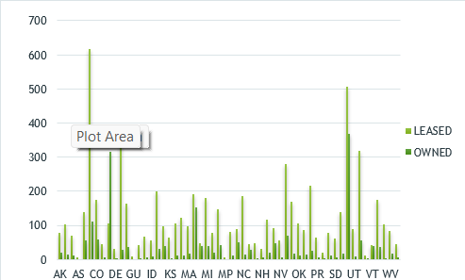

Objective 2: Geographic Distribution of Buildings
- General Description:
Analyze building distribution across states to identify concentrations.
- Specific Requirements:
Use the horizontal bar chart to see the total number of buildings per state.
- Analysis Results:
The bar chart highlights states with more buildings (e.g., UT, DC, AZ).
- Visualization:
Horizontal bar chart showing total buildings per state.

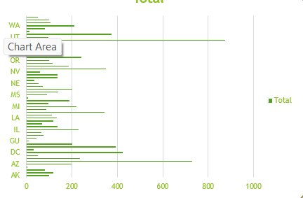

Objective 3: ABA Accessibility Flag
- General Description:
  - Assess the ABA accessibility status of buildings.
- Specific Requirements:
  - Use the donut chart to see percentages of Yes, No, and Will Confirm.

- Analysis Results:
  - 54% are compliant, 42% need confirmation, and 4% are non-compliant.
- Visualization:
  - Donut chart showing ABA compliance percentages.

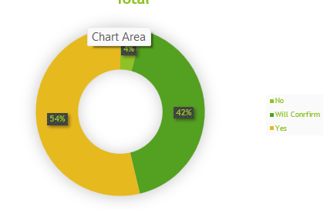
Objective 4: Building Active Status
- General Description:
  - Analyze the current active status of buildings.
- Specific Requirements:
  - Use the donut chart to see percentages of Active, Decommissioned, and Excess.
- Analysis Results:
  - 99% are active, less than 1% are decommissioned, and 1% are excess.
- Visualization:
  - Donut chart showing active status percentages.

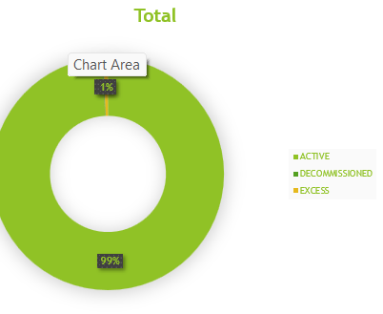

Objective 5: Building Historical Status
- General Description:
  - Analyze the historical status of buildings.
- Specific Requirements:
  - Use the line chart to view the percentages of different historical statuses (e.g., Not Evaluated, National Register Listed) across states.
- Analysis Results:
  - The line chart shows the distribution of various historical statuses across different states. For example, the percentage of "Non-Contributing Element" varies by state.
- Visualization:
  - Line chart displaying historical status percentages by state.

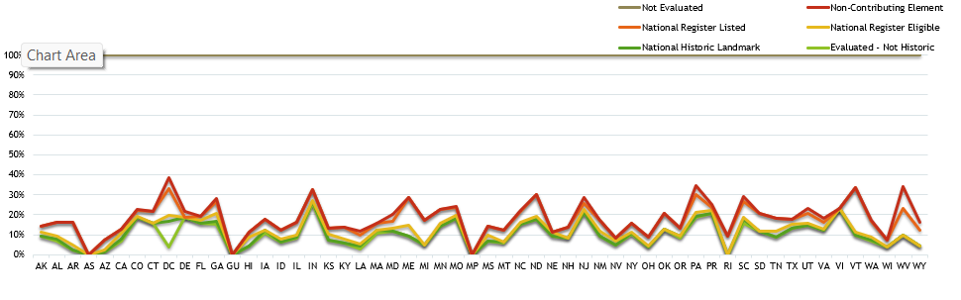

- Conclusion :-
This Canvas document outlines five key objectives for analyzing building data. These objectives cover a range of important aspects, including ownership and leasing trends, geographic distribution, accessibility compliance, active status, and historical significance. The analysis uses a variety of visualizations, such as donut charts, bar charts, and line charts, to provide insights into the data. Each objective is structured to clearly define the analysis goals, data requirements, key findings, and appropriate visualization methods.

LINKEDIN:-

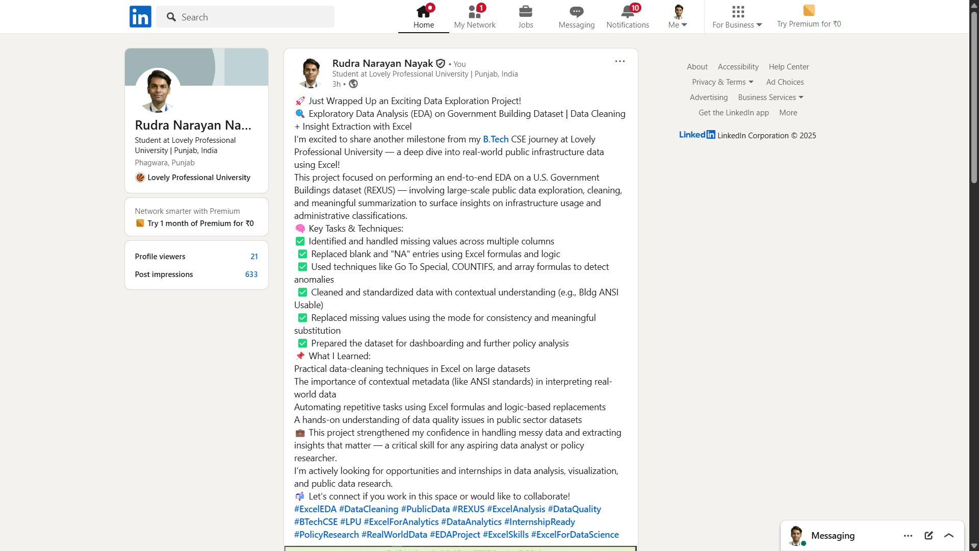
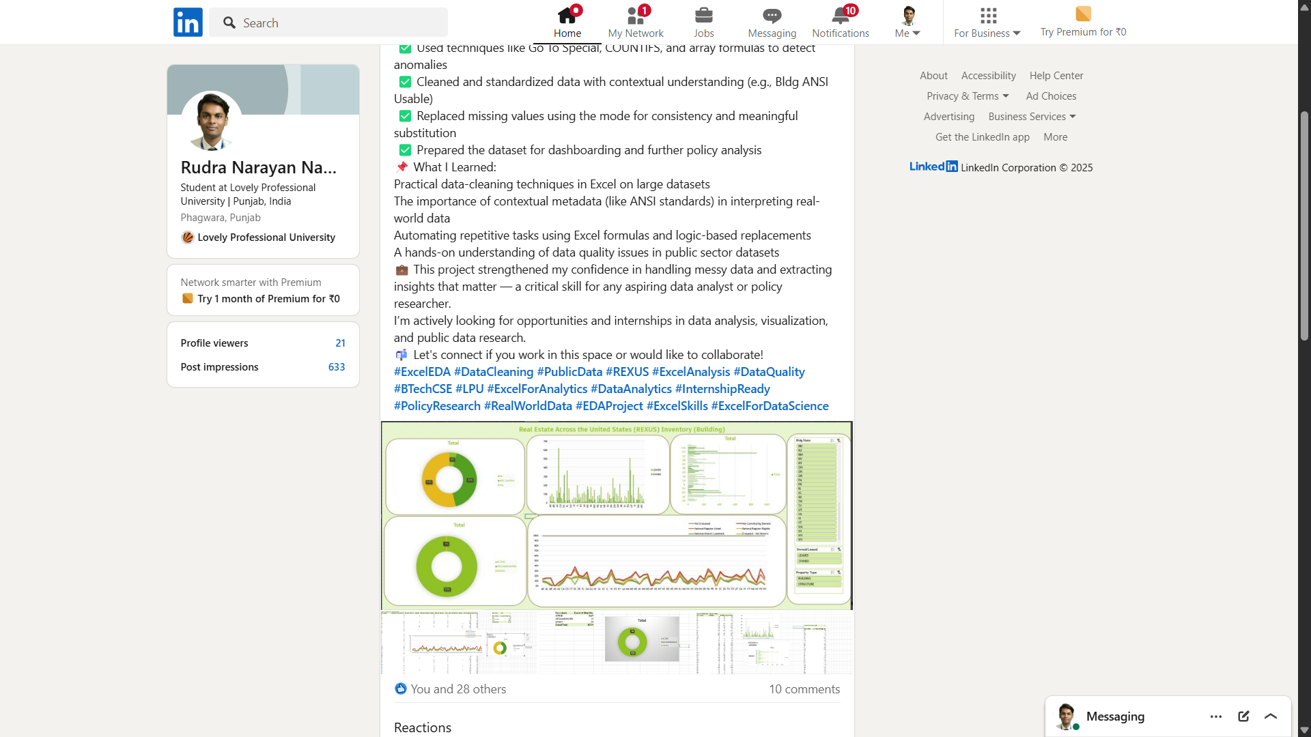

https://www.linkedin.com/feed/update/urn:li:activity:7317178851481006086/

